**Brandes, Georg Morris Cohen (1842-1927)**

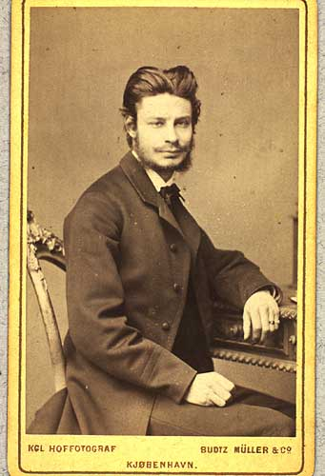

Credit: The Royal Library, Copenha­gen, Department of Maps, Prints, and Photographs

The Danish literary critic Georg Brandes is known as the force behind the modern breakthrough in Scandinavian literature in the late nineteenth century. Inspired by French naturalists such as Hippolyte Taine and Émile Zola, Brandes called for the development of a realistic literary style that debates social problems. His treatise *Hovedstrømninger I det 19de Aarhundredes Literatur* (*Main Currents in Nineteenth Century Literature*) (1872)influenced a generation of Scandinavian and European authors, including August Strindberg, Rainer Maria Rilke, and Arthur Schnitzler. Through his extensive journalistic activity, international lecture tours, and voluminous correspondence, Brandes popularized Scandinavian modernist literature throughout continental Europe, in particular the works of Henrik Ibsen and J. P. Jacobsen. He was instrumental in introducing Søren Kierkegaard and Friedrich Nietzsche to the public. Brandes later focused on writing biographies of “great men,” such as Goethe, Shakespeare, and Caesar, and speaking out against the oppression of minority populations across Europe. His opposition to European imperialism and World War I alienated many supporters, including French prime minister Georges Clemenceau and English scholar William Archer, but earned him the respect of his country, which had declared neutrality.

Born in Copenhagen on February 4, 1842, Georg Brandes is one of the most controversial figures in Danish cultural history. While Denmark celebrates the adoption of its constitution on June 5, 1849 as the beginning of the modern Danish state, the date of Brandes’s first lecture at the University of Copenhagen, November 3, 1871, marks another significant turning point in the development of Danish cultural and social modernity. After studying philosophy and aesthetics at the University of Copenhagen, Brandes visited England and France in the late 1860s, where he encountered the revolutionary ideals of modernist literature. Back in Denmark, Brandes scandalized the Danish establishment by declaring that a country’s literature is entwined with its political vitality. He condemned contemporary Danish literature as a fossilized echo of Romanticism. The socially engaged, realistic literary aesthetic Brandes championed emerged in the works of young Scandinavian writers, the so-called “Men of the Modern Breakthrough,” which included J. P. Jacobsen, Erik Skram, and Holger Drachmann, and inspired German naturalism. The movement’s ideals of social criticism, exemplified by Brandes’s support for civil marriage and women’s emancipation, advanced the liberalization of Danish society and politics, but aroused considerable opposition. Critics accused Brandes of being too cosmopolitan and not Danish enough; his Jewish heritage was often cited as evidence for his unsuitability as a representative of Danish social mores. Brandes lived in Berlin for several years and generally enjoyed greater popularity across Europe than in Denmark. Since his death on February 19, 1927, Brandes’s legacy of historical literary criticism and cultural radicalism has continued to inspire followers and inflame opponents.

**Complete Works**

Brandes, Georg. *Samlede skrifter.* 18 vols. Copenhagen: Gyldendal, 1899-1910.

**List of Works**

*Hovedstrømninger det 19de Aarhundredes Litteratur.* 6 vols.(1872-1890)

*Søren Kierkegaard: en kritisk Fremstilling i grundrids* (1877)

*De moderne gjennembruds mænd* (1883)

*Aristokratisk Radikalisme. En Afhandling om Friedrich Nietzsche.* (1889)

*Henrik Ibsen* (1898)

*Verdenskrigen* (1916)

**Translations**

Brandes, Georg. *Friedrich Nietzsche.* Trans. by A. G. Chater. New York: Macmillian, 1909.

Brandes, Georg. *Henrik Ibsen. Bjornstjerne Bjørnson. Critical Studies.* Ed. by William Archer. Trans. by Mary Morison. New York: Macmillan, 1899.

Brandes, Georg. *Main Currents in Nineteenth Century Literature.* Trans. by Mary Morison and Diana White. 6 vols. New York: Macmillan and London: Heinemann, 1901.

Brandes, Georg. *The World at War.* Trans. by Catherine D. Groth. New York: Macmillan, 1917.

**Secondary Works**

Asmundsson, Doris R. *Georg Brandes. Aristocratic Radical.* New York: New York University Press, 1981.

Nolin, Bertil. *Georg Brandes.* Boston: Twayne, 1976.